SP22 15W CSCI5531.01 Advanced Operating Systems

Project-3 [KSH]



Instruction Manual and architecture

of

UHCL Bulletin Board System

**Developed and designed by**

**Swapnil Patel (1966690)**

Hosted on: https://github.com/swap1210/go-project

Table of Contents

Flow Charts: 3

Execution sequence 3

Execution Steps: 3

Step 1. Log in as Bulletin Board Services 3

Initial setup: 3

List Publications: 3

List Subscribers: 3

Step 2. Log in as Publisher: 4

Initial Setup: 4

Step 3. Login as Subscriber: 4

Initial Setup: 4

Subscriber Menu: 4

Creating a topic 4

Subscribe to topics: 5

On Publish: 5

# Flow Charts:

## Execution sequence

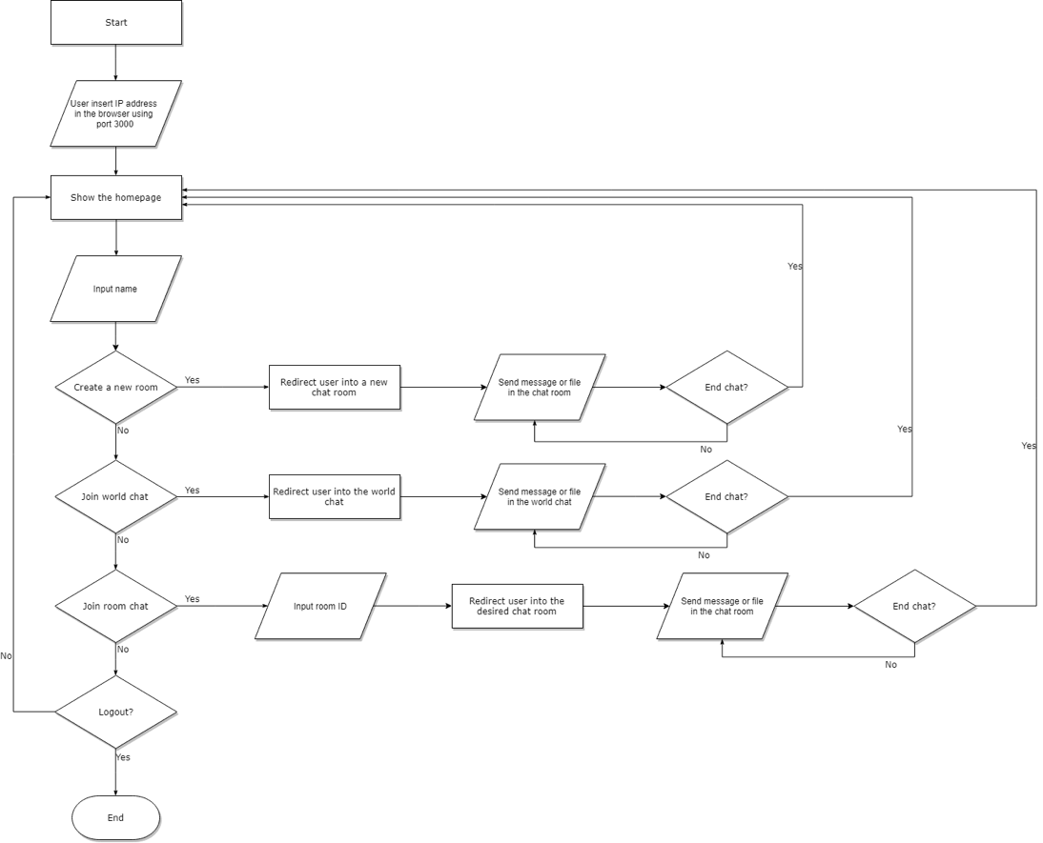

Here the topic is nothing but chat room names. So all the people in the room will receive the message.

# Execution Steps:

## Step 1. Log in as Bulletin Board Services

### Initial setup:

This is the home screen of the Bulletin Board Services, just start it before starting any other system. This can be used to monitor active clients and other activities.



### List Publications:

### List Subscribers:

## Step 2. Log in as Publisher:

### Initial Setup:

This will ask for three inputs namely: Publisher Name; Topic of publication; Bulletin Board Service ip:port.

## Step 3. Login as Subscriber:

### Initial Setup:

Initial setup includes port number on which server started and logs client activities

### Subscriber Menu:

## Creating a topic

### Subscribe to topics:

### On Publish:

